HOW CLEAN IS TOO CLEAN?

Overuse of disinfectants is causing problems for waste treatment plants.

By BEni Grey DATE SePtember 2020

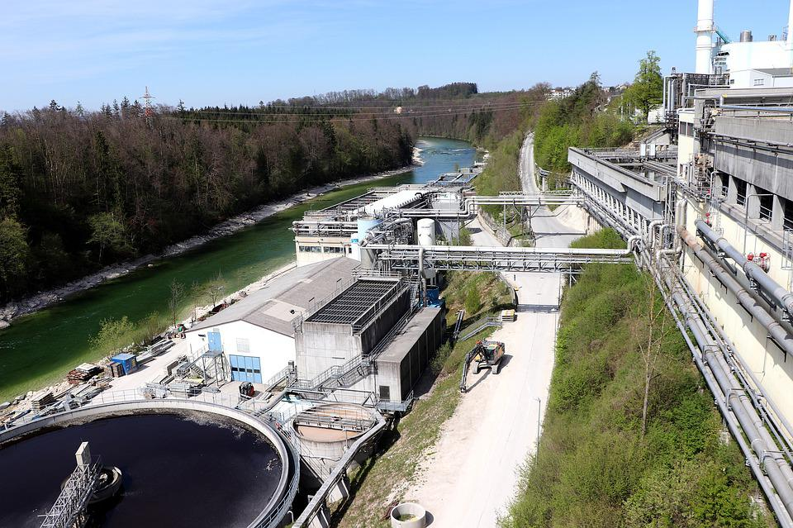
Many wastewater treatments plants use different bacteria to help break down sewage. Now, the overuse of household antimicrobial products could be damaging the effectiveness of these bacteria.
Image from pixabay

As a result of Covid, disinfectants and other cleaning products were more in demand than ever before. Constant wiping and cleaning of surfaces and shared areas was an important tool in helping to prevent the spread of the virus. But now, scientists are warning that there could be an unintended consequence of all this extra cleaning.

One of the common ingredients used in household cleaners to kill germs is called triclosan. The problem starts when too much triclosan is washed down our drains.

Wastewater from our homes, offices and other buildings all enters the sewage system, whether this is from toilets, showers, washing machines or other sources. This sewage is then treated at wastewater or sewage plants to make it safe to release.

Bacteria are an important part of the process of treating sewage because they help to break down harmful substances in the sewage, destroying material that may cause problems to wildlife if it was to be released. The solid waste (sludge) that is produced in this process can also be used as a fertiliser, but only if this has been broken down enough by the bacteria.

Triclosan is an antimicrobial, which means that it destroys bacteria and other microorganisms. When people use cleaning products containing triclosan and then flush it down the drain, it can thwart the helpful bacteria in their sewage treatment mission.

Researchers at Marquette University in Milwaukee, Wisconsin (USA) investigated the effect that triclosan had on the bacteria in the sewage treatment process. They found that when exposed to high concentrations of triclosan, the bacteria were much less effective in breaking down harmful substances, and in extremely high doses, stopped working at all.

Scientists are now aware that there needs to be a balance between keeping people safe from harmful germs and making sure that these chemicals do not disrupt the waste treatment process. The knock-on effects of sewage not being broken down properly before it is released could be catastrophic for wildlife. However, the consequences of people using less disinfectant or reducing cleaning could accelerate the spread of harmful diseases.

The researchers agree that it is important for people to be aware of what happens to our waste and how we can help this process keep running smoothly and safely.

Answer the following questions in full sentences:

- What is this news story about?
____________________________________________________________________________________
____________________________________________________________________________________
____________________________________________________________________________________

- What was the conclusion of the experiment?
____________________________________________________________________________________
____________________________________________________________________________________
____________________________________________________________________________________

- How could the amount of triclosan in treatment plants be lowered?
____________________________________________________________________________________
____________________________________________________________________________________
____________________________________________________________________________________

- Why may these findings be particularly relevant today?
____________________________________________________________________________________
____________________________________________________________________________________
____________________________________________________________________________________

- Write down the meanings of any words in bold in the article.
____________________________________________________________________________________
____________________________________________________________________________________
____________________________________________________________________________________
____________________________________________________________________________________
____________________________________________________________________________________
____________________________________________________________________________________

